Java Documentation
PROJECT 3 DOCUMENTATION
Project Name
ATM Interface
Objective
The objective of this project is to develop a Java-based ATM Interface that allows users to perform banking operations such as checking account balance, depositing money, withdrawing money, and viewing transaction history. The project demonstrates the implementation of Object-Oriented Programming (OOP) concepts in Java.
Introduction
The ATM Interface is a Java application that simulates the basic functionalities of an Automated Teller Machine (ATM). It provides a secure and user-friendly environment where users can access banking services through PIN authentication. This project helps in understanding classes, objects, methods, encapsulation, and user interaction in Java.
Tools and Technologies Used
- Java
- JDK (Java Development Kit)
- VS Code / IntelliJ IDEA
- Scanner Class
- ArrayList Collection Framework
Key Features
- PIN Authentication
- Balance Inquiry
- Deposit Money
- Withdraw Money
- Transaction History
- Input Validation
- User-Friendly Menu System
- Secure Banking Operations
Algorithm
- Start the program.
- Create a Bank Account object with an initial balance.
- Authenticate the user using a PIN.
- Display the ATM menu.
- Allow the user to choose an operation:
  - Check Balance
  - Deposit Money
  - Withdraw Money
  - View Transaction History
  - Exit
- Perform the selected operation.
- Update account information accordingly.
- Store transaction details in history.
- Repeat until the user chooses Exit.
- Display a thank-you message and terminate the program.
OOP Concepts Used
Class
- BankAccount Class
- ATM Class
- ATMInterface Class
Object
- BankAccount object
- ATM object
Encapsulation
- Balance variable declared as private.
- Data accessed through methods.
Methods
- deposit()
- withdraw()
- checkBalance()
- showHistory()
- start()
Modules
BankAccount Module
- Stores account balance.
- Handles deposits and withdrawals.
- Maintains transaction history.
ATM Module
- Verifies user PIN.
- Displays ATM menu.
- Manages user operations.
Main Module
- Creates objects.
- Starts the ATM system.
Output Screenshot
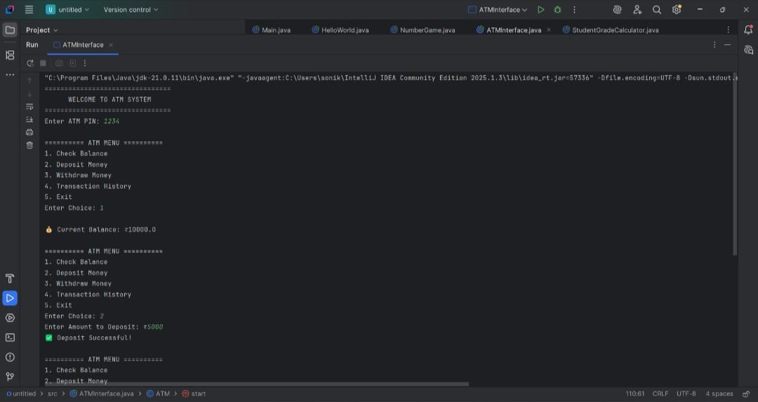
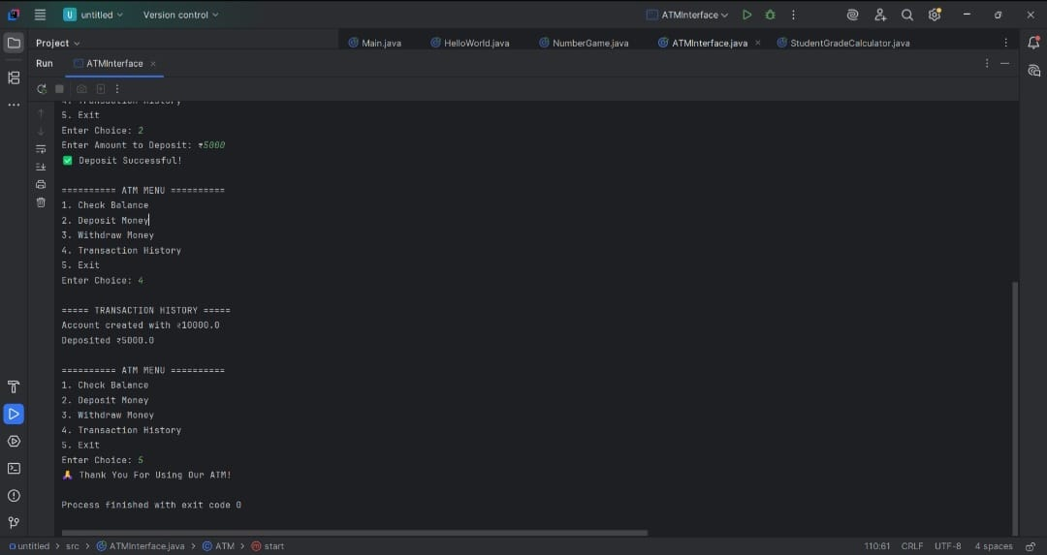

Advantages
- Secure user authentication
- Easy banking transactions
- Real-time balance updates
- Transaction tracking
- Demonstrates OOP concepts effectively
- User-friendly interface
Applications
- Banking Systems
- ATM Software Simulation
- Financial Management Applications
- Learning Object-Oriented Programming
Conclusion
The ATM Interface project was successfully developed using Java and Object-Oriented Programming principles. The system provides essential banking operations such as balance inquiry, deposit, withdrawal, and transaction history management. This project enhanced the understanding of classes, objects, encapsulation, methods, and real-world software design concepts in Java.

